27.85: a)
b) 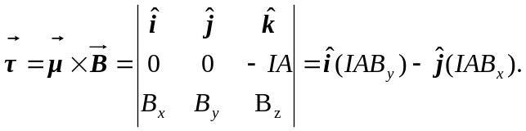
But
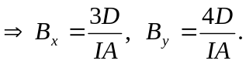
But 